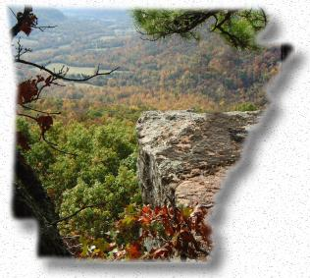


Arkansas USA

GEOGRAPHY
Arkansas is near the geographic and population centers of the United States. Its borders adjoin Texas, Louisiana, Mississippi, Tennessee, Missouri, and Oklahoma with the Mississippi River forming the state’s eastern border.

It is located on the same latitude as Osaka, Japan and North Africa.

Land Surface
34,036,717 acres

East~Alluvial valleys of the Arkansas and Mississippi rivers, with agricultural land dominated by cotton, rice
and soybeans

North and West~Mountainous or coastal plains

South~Wildlife refuges and timberlands

Source: Arkansas Forestry Commission

Climate
Temperate with four seasons, long summers and short winters.

Temperature
Annual maximum 72.9°F
Annual minimum 52.5°F

Humidity
Annual relative at noon for Arkansas 49%

Precipitation
Total annual for Arkansas 50.6 inches

Source: www.srh.noaa.gov

POPULATION
Arkansas (2010 Census) | 2,915,919
Arkansas (2017 Estimate) | 3,004,279
Arkansas (2020 Projection) | 3,286,837
United States (2010 Census) | 308,745,538
United States (2017 Estimate) | 325,719,178
United States (2020 Projection) | 334,503,458
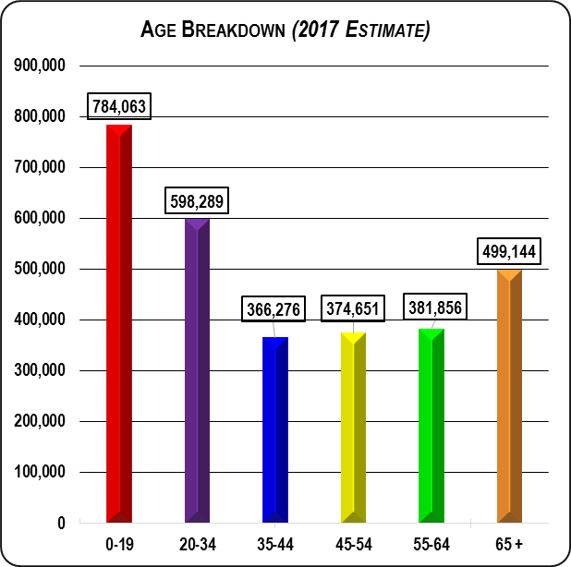
Arkansas Profile – 1
October 2018

Major Urban Centers Population

(2017 Estimate)
Pine Bluff, AR MSA | 90,963
Hot Springs, AR MSA | 98,658
Jonesboro, AR MSA | 131,269
Texarkana, TX-AR MSA | 150,355
Fort Smith, AR-OK MSA | 282,086
Fayetteville-Springdale-Rogers, AR-MO MSA | 537,463
Little Rock-North Little Rock-Conway, AR MSA | 738,344
Memphis, TN-MS-AR MSA | 1,348,260

Source: U. S. Census Bureau

NATURAL RESOURCES

Environmental Regulation
Consistent with other states. The Arkansas Department of Environmental Quality issues air, water, and solid waste permits.

Water
Arkansas has over 283,000 hectares (699,293 acres) of surface water. Over 800 billion liters of high quality ground water are contained in aquifers capable of yielding over 2,000 liters per minute.

Source: Arkansas Department of Environmental Quality (Water Division)

Timber
Forests cover 18.8 million acres or more than half of the state. Pine woods make up 41%, and the rest is mixed hardwoods, mostly oak.

Timber growing, harvesting, management, transporting, and processing are major industries in Arkansas.

Source: Arkansas Forestry Commission

Minerals
Commercial Production~Bromine (#1 in world), cement rock, clay, gypsum, novaculite, quartz crystals, stone, sand and gravel.

Source: Arkansas Geological Survey

Oil

Crude Oil
Total Production 5,288 thousand barrels (2017)
Reserves 40 million barrels (2016)

Natural Gas
Total Production 707,292 million cubic feet (2017)
Reserves 7,420 billion cubic feet (2016)

Coal
Total Production 49 thousand short tons (2016)
Number of Mines 3 (2016)

Source: U. S. Energy Information Administration

BUSINESS CLIMATE

Market
40% of the U.S. population is within one day’s drive of Arkansas. Major market centers in the region include: Memphis, Chicago, Atlanta, Dallas, Fort Worth, Houston, Kansas City, Oklahoma City, New Orleans, and St. Louis.

Arkansas Profile – 2
October 2018
Fortune 500
There are more than 95 Fortune 500 firms with more than 2,500 operations in Arkansas. Six of the firms, Walmart Stores, Inc., Tyson Foods, Inc., Murphy USA, J. B. Hunt Transport Services, Dillard’s, Inc., and Windstream Holdings are headquartered here. ArcBest and Murphy Oil Corporation also headquartered here are part of the Fortune 1000.

Source: Arkansas Economic Development Commission

Gross Domestic Product
(Millions of current dollars) 2017
Total Gross Domestic Product | $124,918
Services | 25.0%
Finance/insurance/ real estate | 15.0%
Manufacturing | 15.0%
Wholesale & Retail Trade | 15.0%
Government | 13.0%
Agriculture/forestry/fishing/hunting/mining | 4.0%
Construction | 4.0%
Transportation/warehousing | 4.0%
Information | 3.0%
Utilities | 2.0%

Source: Bureau of Economic Analysis

Retail Sales
(Top 5 Retail Sectors) 2017
Total Retail Sales | $41,410,164,662
Motor Vehicles & Parts Dealers | 9,098,225,626
General Merchandise | 8,075,344,988
Gasoline Stations | 5,580,866,072
Food and Beverage Stores | 4,876,003,064
Food Services & Drinking Places | 3,585,240,011

Source: Economic and Social Research Institute (ESRI)

Principal Industries
Manufacturing, agriculture, forestry, transportation, information, business services and tourism.

Principal Manufactured Goods
Food and Kindred Products, Lumber and Wood Products, Paper and Pulp, Electronic Equipment, Rubber and Plastic Products, Machinery, Transportation Equipment, Chemicals, and Fabricated and Primary Metals.

Source: Arkansas Economic Development Commission

Industrial Manufacturing Structure 2017
Number of Industry Establishments
Fabricated Metal Product Manufacturing | 515
Wood Product Manufacturing | 320
Food Manufacturing | 287
Printing/Related Support Activities | 242
Nonmetallic Mineral Product Manufacturing | 235
Machinery Manufacturing | 211
Miscellaneous Manufacturing | 170
Furniture/Related Products Manufacturing | 162
Transportation Equipment Manufacturing | 135
Plastic/Rubber Products Manufacturing | 123
Chemical Manufacturing | 123
Primary Metal Manufacturing | 76
Paper Manufacturing | 72
Electrical Equipment/Appliances | 57
Beverage & Tobacco Product Manufacturing | 54
Computer/Electronic Product Manufacturing | 51
Textile Product Mills | 44
Petroleum/Coal Products Manufacturing | 20
Apparel Manufacturing | 16
Leather/Allied Products Manufacturing | 15

Source: Arkansas Covered Employment & Earnings

Principal Agricultural Products 2017

Rice (#1 in nation) 82.6 million hundredweight
Cotton (#4 in nation) 1.10 million bales
Poultry (#3 in nation) 1,059,000 birds
Soybeans (#11 in nation) 179 million bushels
Wheat 6.5 thousand bushels

Source: USDA-Arkansas Field Office

Tourism
Tourists spent more than $7.8 billion in Arkansas in 2017; the Ozark and Ouachita Mountain Regions and the Buffalo National River are popular recreational areas. The Crater of Diamonds State Park near Murfreesboro is the only diamond producing site in the world open to the public.

Source: Arkansas Department of Parks & Tourism

Arkansas Profile – 3
October 2018

Transportation

Highways
Interstate (4 or 5 lanes) 948 kilometers (589.40 miles)
NHS*(4 or more lanes) 853 kilometers (530.50 miles)
NHS*(2 lanes) 2,482.40 kilometers (1,542.82 miles)
*National Highway System

Source: U.S. Highway & Transportation Administration

Truck and Motor Freight
Some of the nation’s leading trucking companies are headquartered in Arkansas. These include ABF Freight System, J. B. Hunt Transport, Maverick Transportation P.A.M. Transport, and USA Truck.

Source: Little Rock Chamber of Commerce

Railroads
Of the twenty-five railroad companies in the state, three are Class I (Burlington Northern Santa Fe, Kansas City Southern and Union Pacific) and 22 are short line.

Class I | 3,045.84 kilometers (1,893 miles)
Short line | 1,433.62 kilometers (891 miles)

Source: Arkansas Business

Airports
The state has approximately 100 public use airports. Commercial service is provided by six airlines at the Bill and Hillary Clinton National Airport and by four airlines NWARA near Bentonville. Commuter service is also available at El Dorado, Fort Smith, Harrison, Hot Springs, Jonesboro, Mountain Home, Pine Bluff and Texarkana.

Source: Source: www.fly-lit.com (Bill and Hillary Clinton National Airport), www.flyxna.com and www.airnav.com

Waterways
Arkansas has one of the largest inventories of navigable waterways in the nation with 1,099 kilometers (more than 1,000 miles) along five rivers. A navigable river is within 65 miles of every county in the state.

Nine cities have public terminals:
Mississippi River~Osceola, West Memphis, Helena-West Helena, and Yellow Bend near McGehee.
Arkansas River~Little Rock, Pine Bluff, and Fort Smith
Ouachita River~Camden and Crossett

Source: Arkansas Waterways Association

EMPLOYMENT

Labor Force
(In thousands)
 | 2015 | 2016 | 2017
Labor Force | 1,330,099 | 1,342,691 | 1,354,265
Employment | 1,260,615 | 1,288,994 | 1,304,434
Unemployment | 69,484 | 53,697 | 49,831
Unemployment Rate | 5.2 | 4.0 | 3.7
Nonfarm Payroll Jobs | 1,209,300 | 1,227,500 | 1,248,800
Mining, Logging & Construct. | 57,200 | 57,600 | NA
Manufacturing | 155,200 | 154,800 | NA
Trade, Trans./Utilities | 250,900 | 252,200 | NA
Information | 13,500 | 13,600 | NA
Financial Activities | 49,900 | 51,200 | NA
Prof. /Business Serv. | 138,700 | 142,500 | NA
Education/Health Serv. | 175,100 | 181,400 | NA
Leisure/Hospitality | 111,700 | 115,400 | NA
Other Services | 44,600 | 43,700 | NA
Government | 212,700 | 212,400 | NA

Source: Arkansas Department of Workforce Services

Income and Wages
(Current dollars) 2017
Earnings & Income | Arkansas | USA
Average Hourly Earnings | $20.45 | $26.09
Per Capita Personal Income | $40,791 | $50,392

PERSONAL INCOME BY SOURCE
(Thousands of dollars) 2017
Earnings by Industry
Farm earnings | 1,288,268
Nonfarm earnings | 74,654,601
Forestry, fishing, related activities | 577,615
Mining, quarrying, and oil and gas extraction | 529,341
Construction | 4,541,172
Manufacturing | 9,490,299
Wholesale Trade | 3,961,011
Retail Trade | 5,141,864
Transportation and warehousing | 3,797,476
Finance, and Insurance | 2,617,655
Government and government enterprises | 13,154,197
Dividends, Interest, Rent | 27,787,335
Transfer Receipts | 29,062,178
Total Personal Income | 123,313,411

Source: Bureau of Economic Analysis

Arkansas Profile – 4
October 2018
Employment Distribution 2017
Trade, Transportation & Utilities | 21.0%
Education & Health Services | 15.5%
Government | 14.9%
Manufacturing | 13.3%
Professional & Business Services | 12.2%
Leisure & Hospitality | 9.9%
Construction | 4.3%
Financial Activities | 4.2%
Other Services | 2.1%
Natural Resources & Mining | 1.4%
Information | 1.1%

Source: Arkansas Covered Employment & Earnings

EDUCATION
Four-year Public Universities 11
Secondary Area Technical Centers 27
Two-year Public Colleges 22
Independent Colleges and Universities 14

Source: Arkansas Department of Higher Education and
Arkansas Department of Career Education

Financing Available
- Municipal and County Industrial Revenue Bonds
- General Obligation Bonds
- State Loan/Guarantee Programs
- Development Finance Corporations
- Diamond State Ventures (Venture Capital)

Foreign Trade Zones (FTZ)
Foreign Trade Zones are located at the Little Rock Port and West Memphis Port. Active Little Rock subzones are located in De Queen, El Dorado and Nashville.

Labor Laws
Right-to-work law forbids compulsory union membership for employment. Minimum wage is set by state and federal laws.

Source: Arkansas Economic Development Commission

